To run basic rest API listening on port 8080

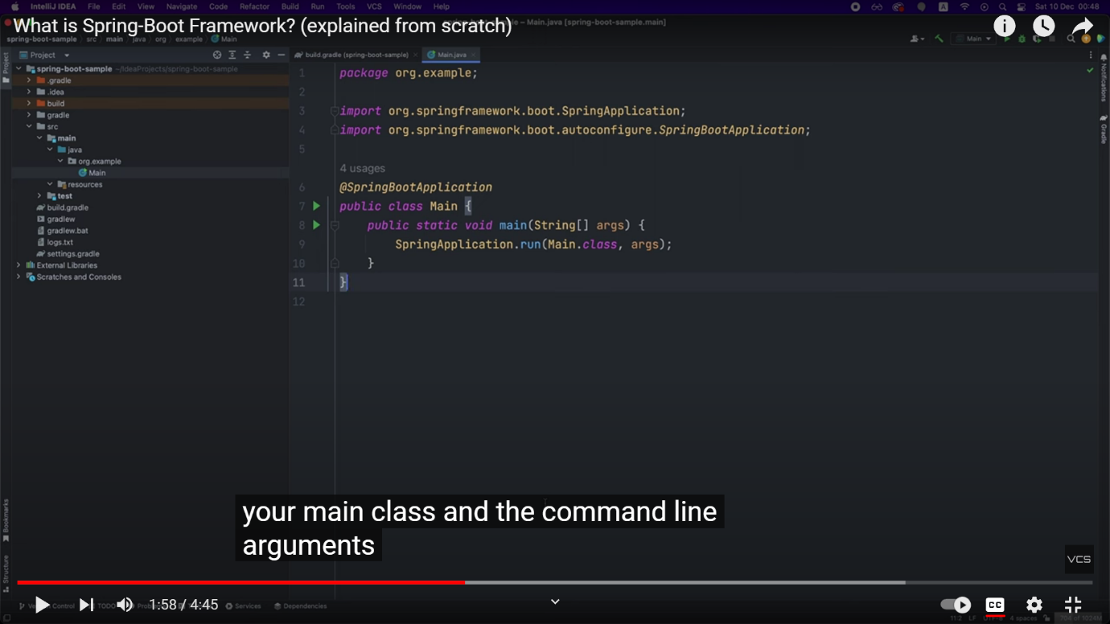

To handle a “GET” request

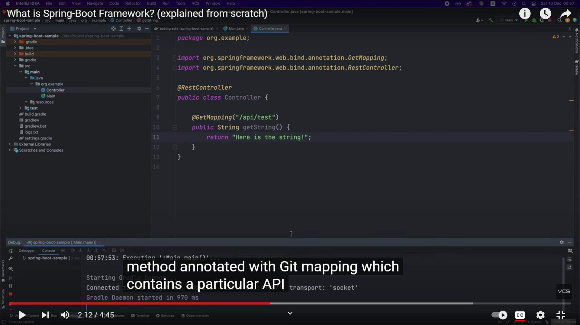

You can also add variables to get a particular information

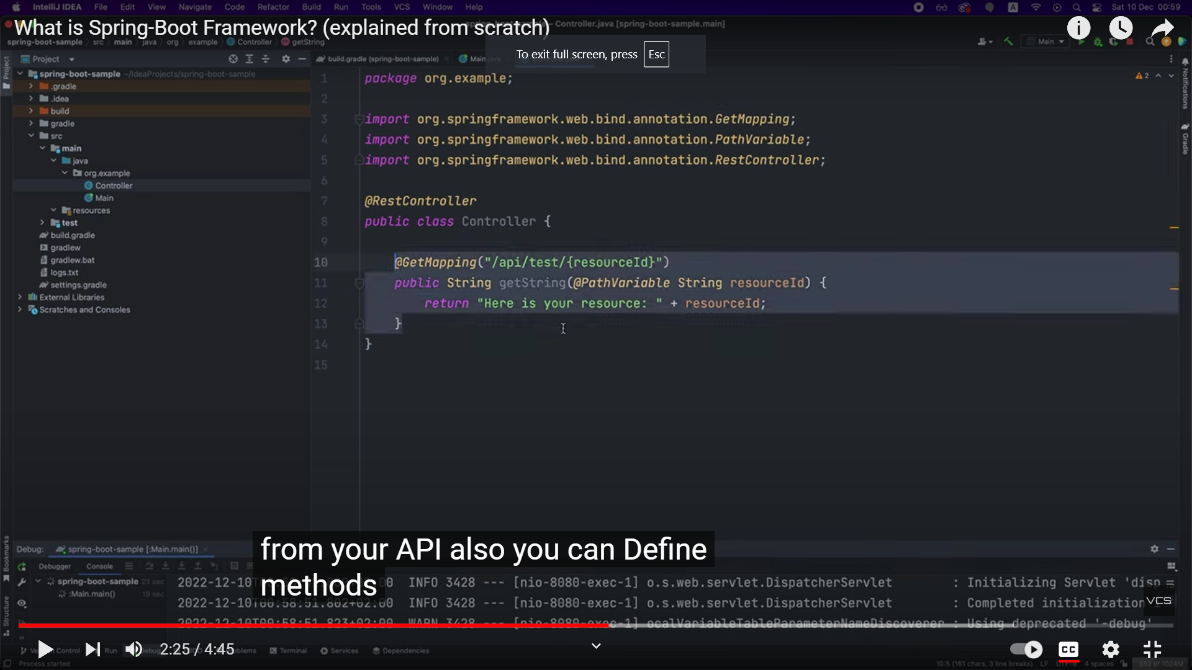

You can also handle “POST” requests and you can receive the req body into a JAVA object

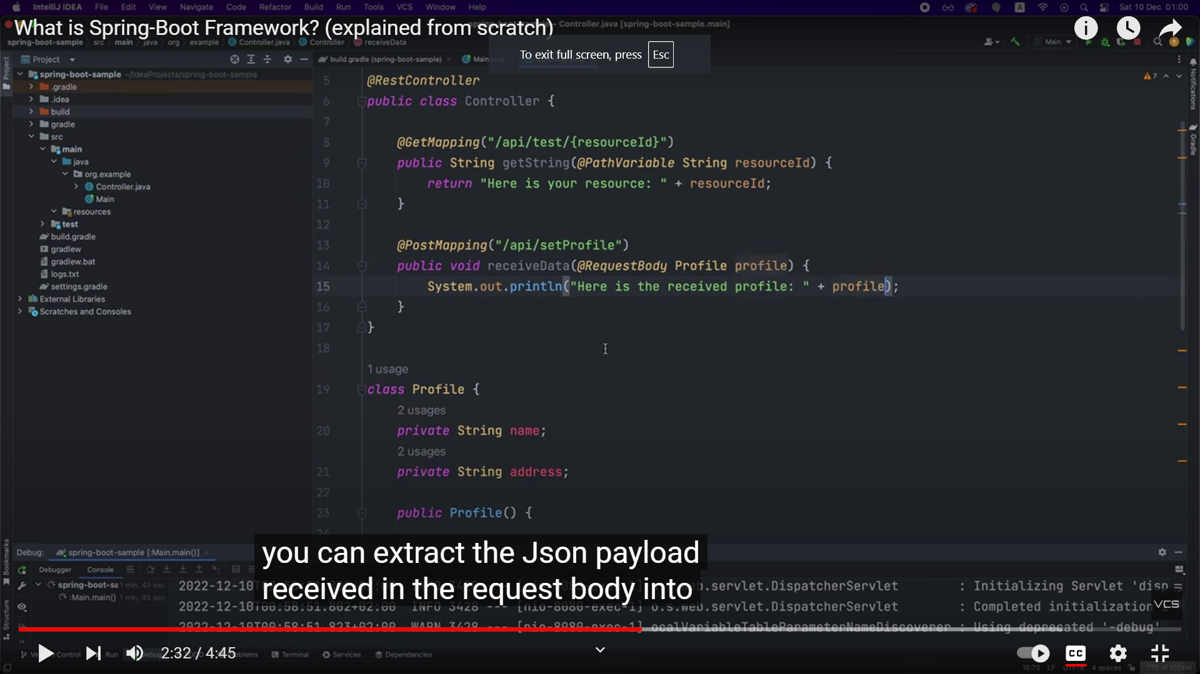

To change configurations, you can add an application.yaml file. To save the application logs in a dedicated file, you can use logging and add a file name for ex. “logs.txt” and will be saved in the root directory of the project

